**Advanced Programming in Java**

**Creating Basic Java Application Projects with JCreator**

In this course we will be creating projects for each program that we write.

1. Create a folder on your desktop called MyJava
2. Start JCreator (we are using version 4.5)
3. Select File|New|Project from the menu which will start the Project Wizard.

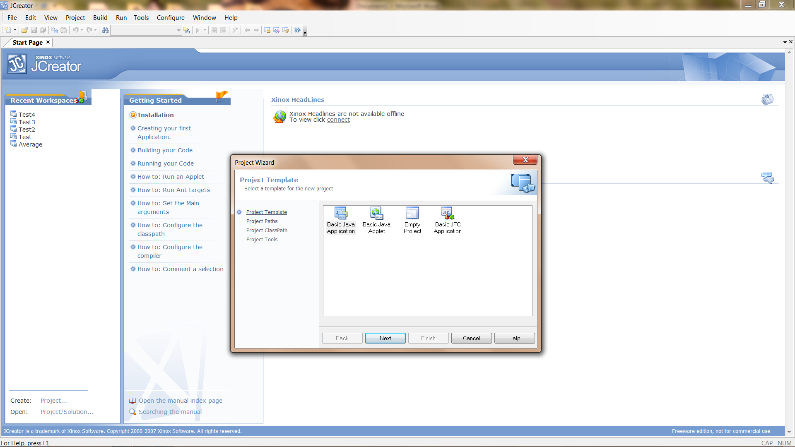

1. Select Basic Java Application Project and click Next.

Enter the Project name and navigate to the MyJava folder on your desktop. I used Hello.

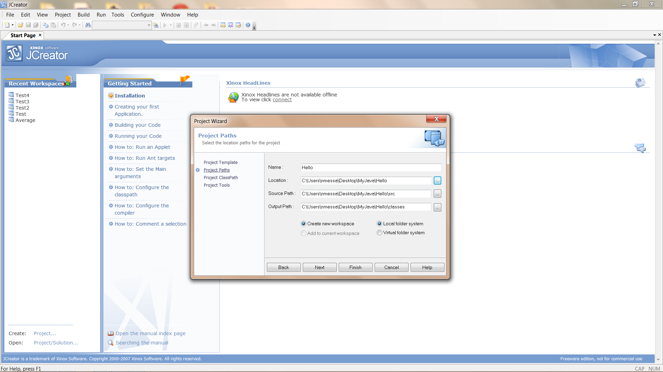

1. Click Next

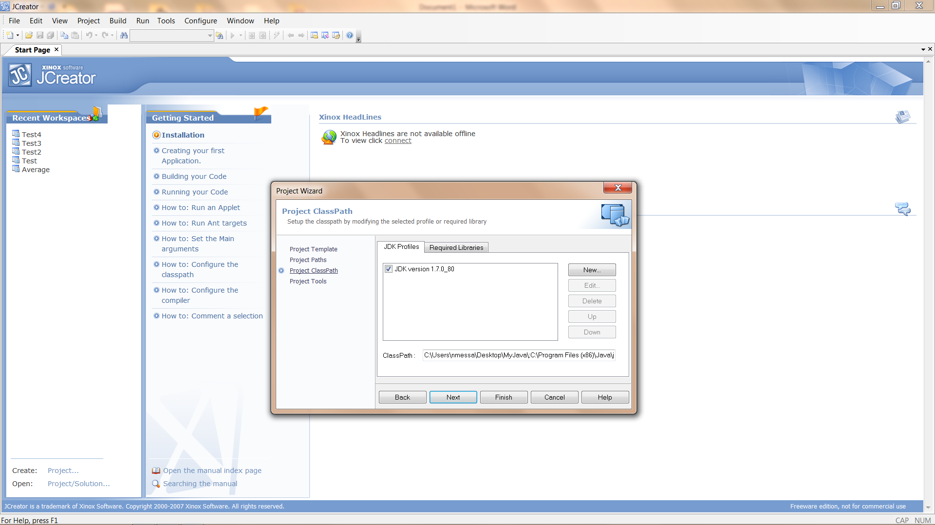

1. Click Next

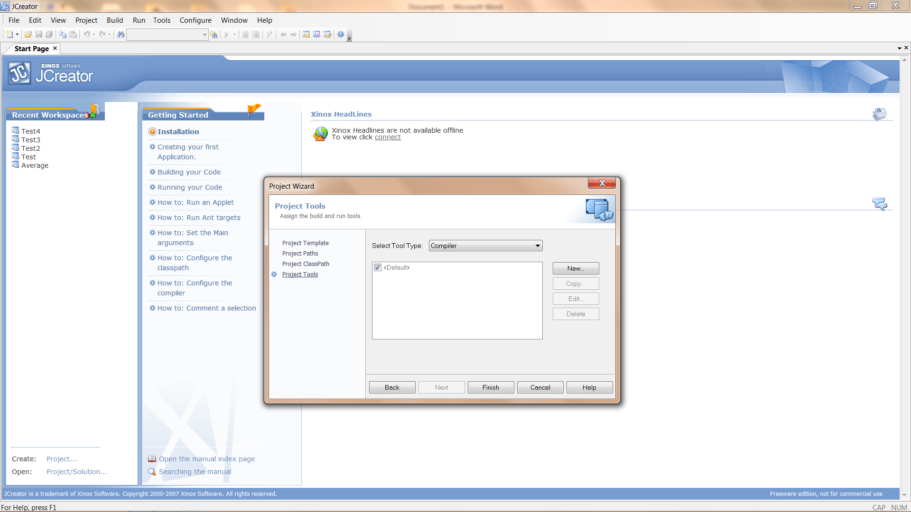

1. Click Finish

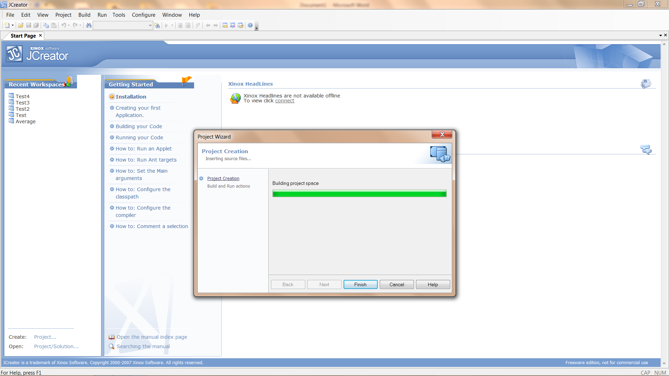

1. When the project has completed building, click Finish

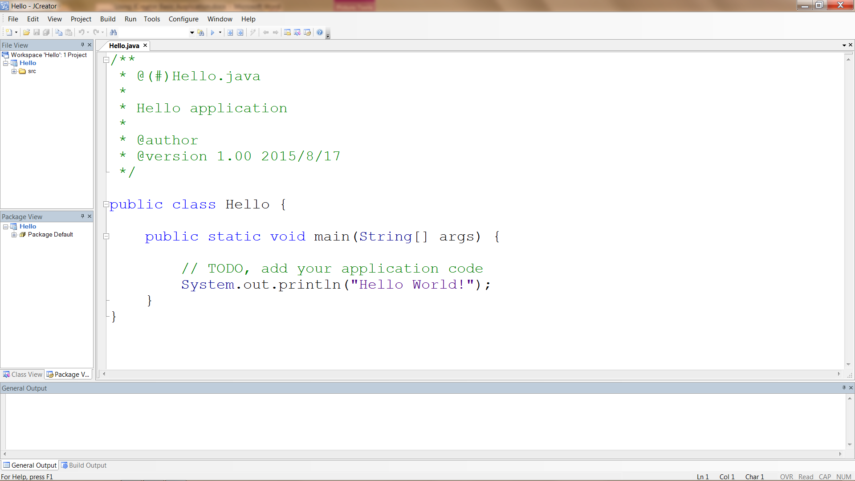

At this point we have a Basic Java Project which includes a Class Hello with a main method that will print “Hello World!” to the console. If you look inside the Hello folder (inside the MyJava folder) you will see 3 files (Hello.jcp, Hello.jcu, and Hello.jcw) and 2 folders (src and classes).

1. Click on the Run Project button and you should get a Process Complete message.

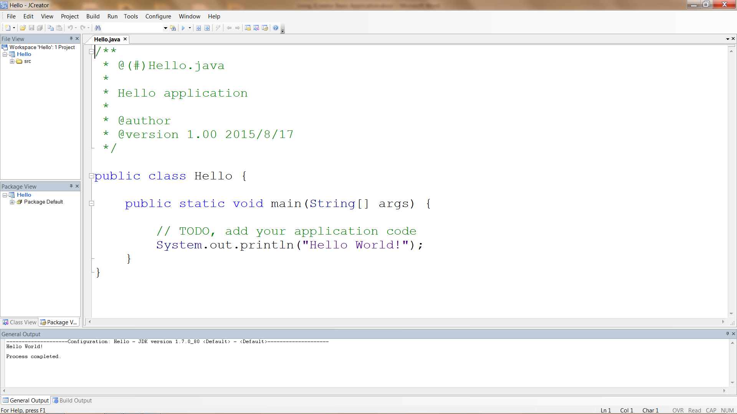

1. Now take a look in the MyJava\Hello folder. You should see Hello.java inside the src folder and Hello.class inside the classes folder.